Date:

**EXPERIMENT: 5**

**AIM:** MOOC on Google Workspace.

**SCREENSHOT OF CERTIFICATE/ BADGE:**

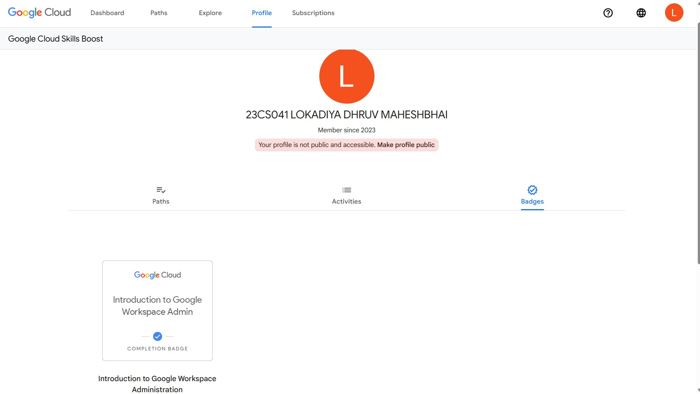

**SCREENSHOTS OF QUIZZES/ASSIGNMENTS SUBMITTED DURING MOOC:**

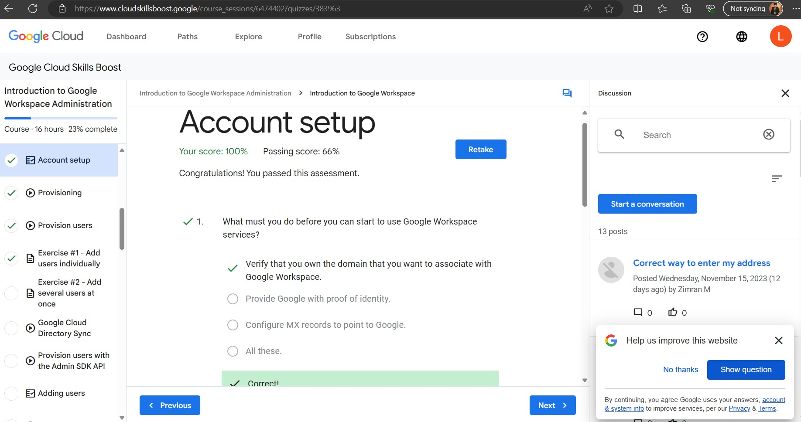

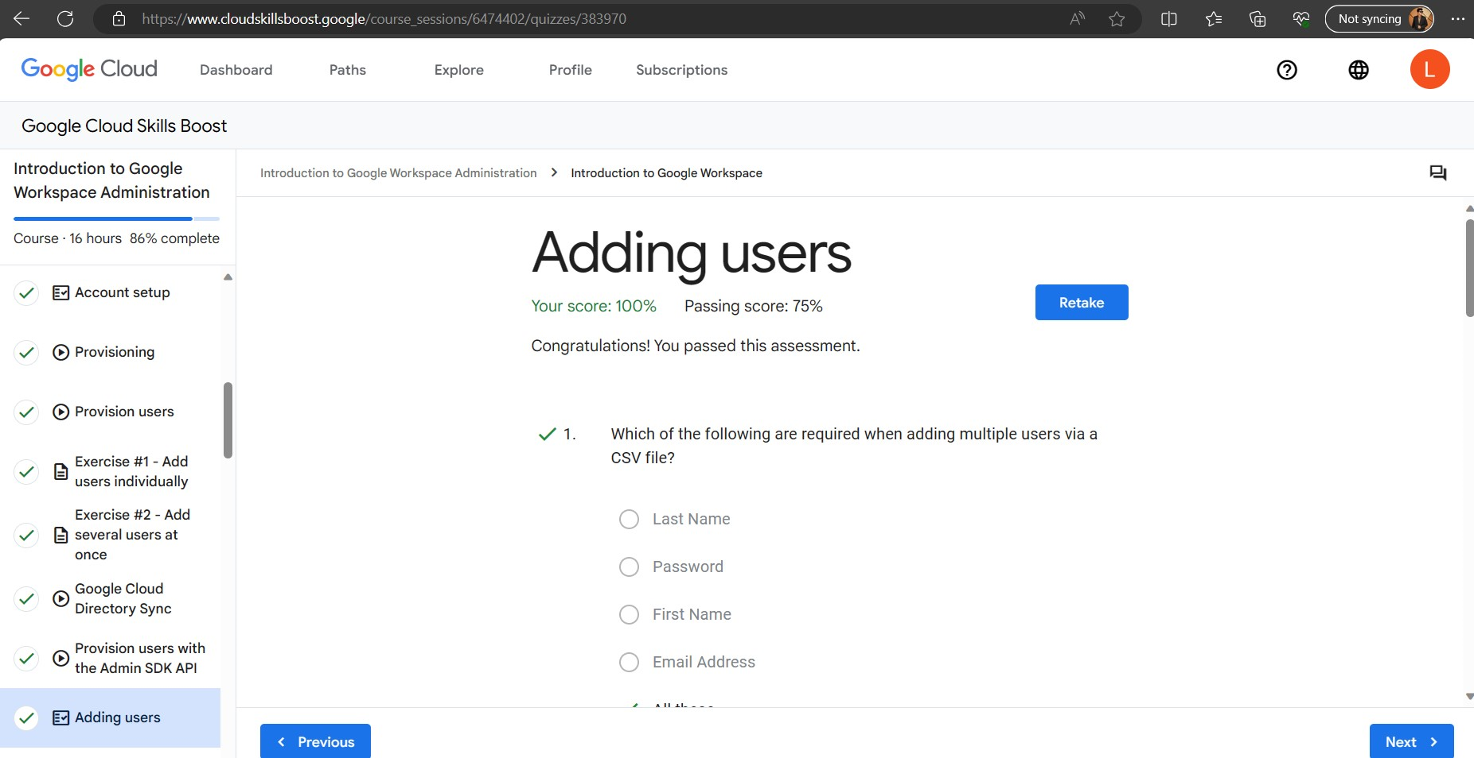

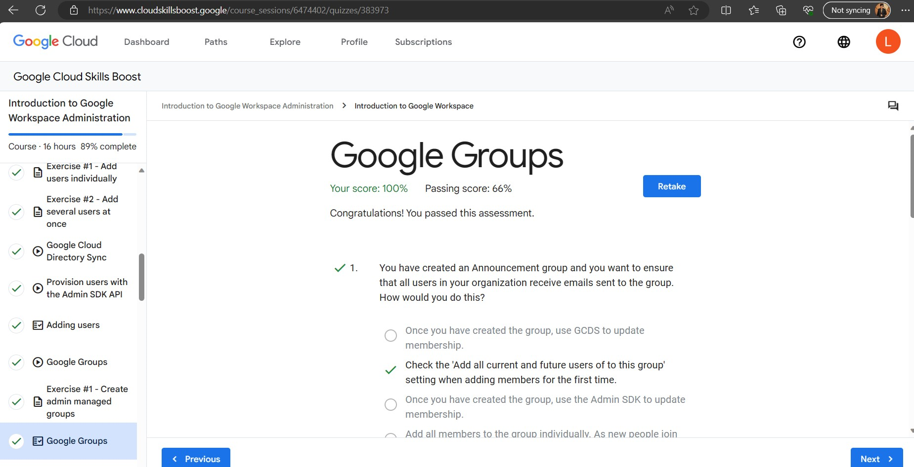

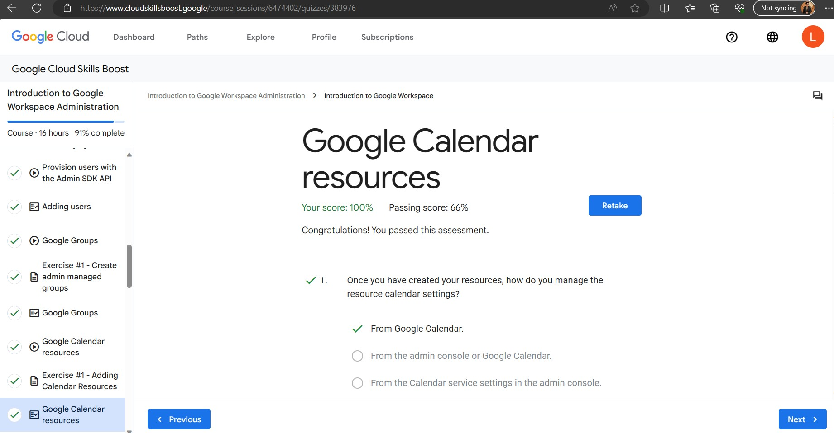

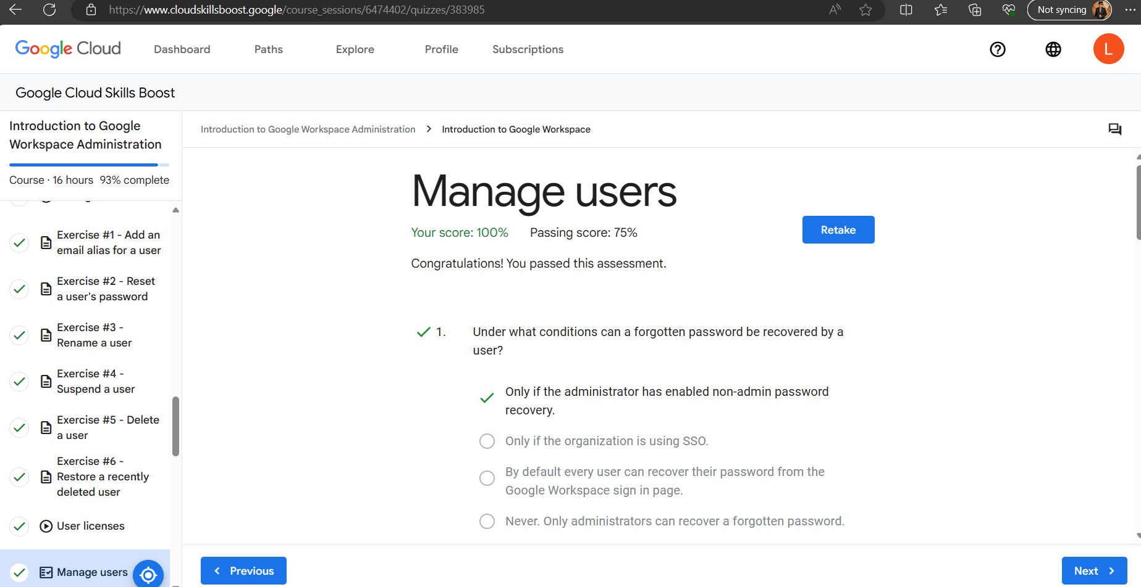

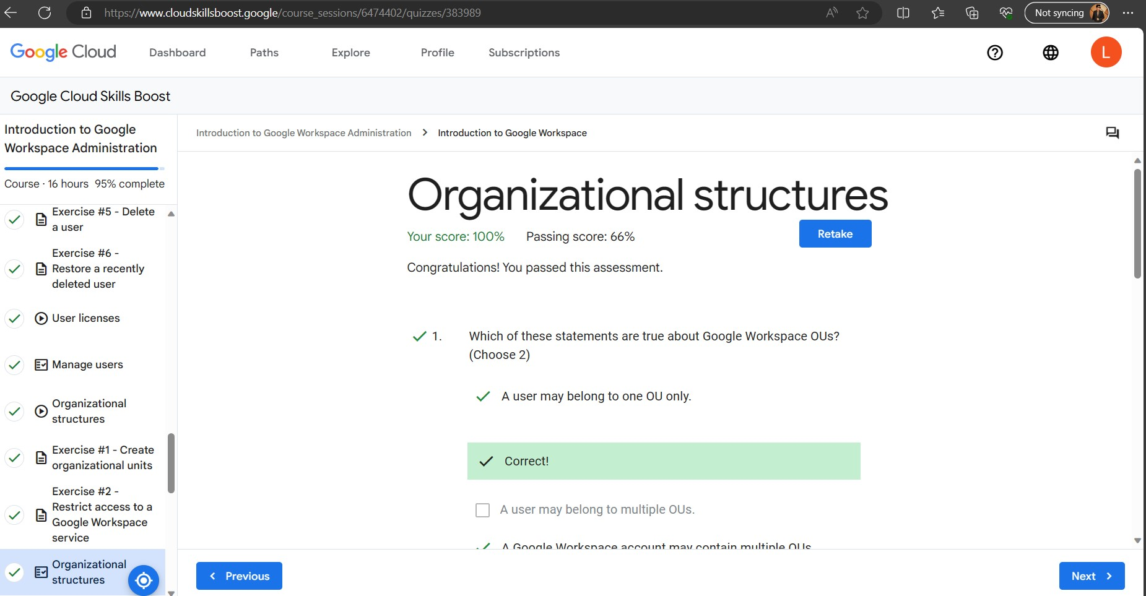

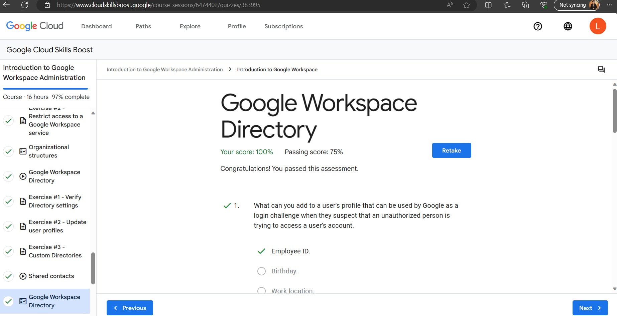

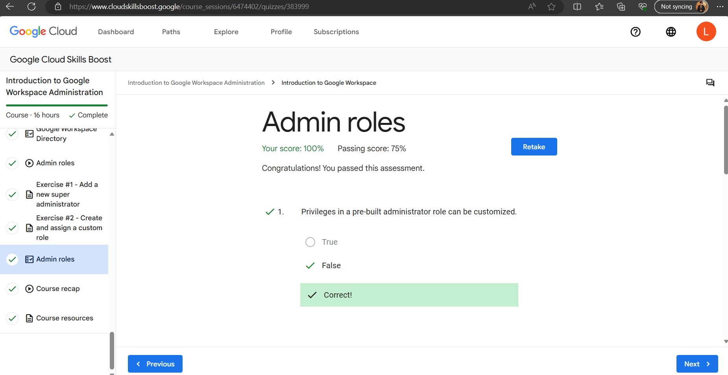

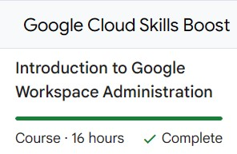

**LINK OF YOUR GOOGLE SITE:**

<https://sites.google.com/charusat.edu.in/dhruvlokadiya>